Holding an energy day

Planning the event

In advance
Start thinking in detail about the event well in advance – and don’t leave anything to the last minute. Don’t try and do everything yourself, either. Organising a whole event can be a lot for one person to take on, so share out the jobs.
These roles could include:
- advertising
- bookings
- event hire
- refreshments
- resources
- speakers
- follow-up

Arrangements
What are the logistics of the event? Have a think about where you might hold it, and how this could have an effect. What are the timings of the day? Make sure you have enough time between each event. If you have a break, remember it will take 5 minutes to get everyone settled again afterwards, so factor this time in.
And who’s responsible for what? A detailed plan for the day is essential and should cover:
- arriving
- setting up
- parking
- introductions
- workshops
- resources
- refreshments
- packing up
- instructions for exhibitors or speakers
- contact numbers

Money
If you’ve budgeted in advance, you could try and fundraise to cover costs. You might hold a raffle, find a local business that will sponsor you, ask exhibitors to contribute (although non-profit organisations may not be able to afford this), etc. Why not try approaching your local county, district, town or parish council or the Volunteer Development Agency?

Think “outside the box”
Is it possible to make the focus of the event something other than energy? Could you ‘piggy back’ on another event? What about linking energy and sustainability to other issues like: food and drink/farmers’ market, DIY, home finances, dieting, film showings, clothes swap?

Getting people to come along

Spread the word
A website or presence on social media (e.g. Facebook) is important. A brief press release sent to your local paper can help – but keep it short and only include the most important points. Also send articles to local newsletters (parish magazines, school newsletters, etc.).
And see if you can get in touch with one or more of your local radio stations, too.
If you have the budget, why not consider leafleting your town or village? If you can’t afford the whole community, think of places where people read them – cafes, libraries, pubs, hairdressers, churches, schools, shops and community buildings.

Catch people’s eye
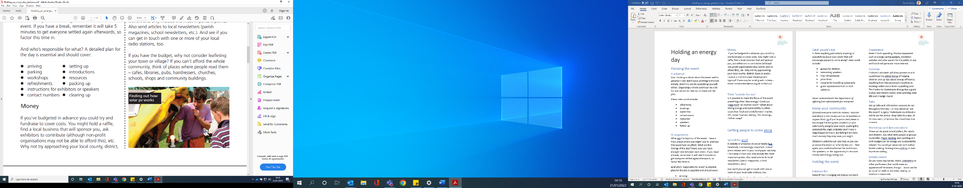
Is there anything particularly inspiring or eyecatching about your event that will encourage people to come along? Ideas could include:
- games for children
- interesting speakers
- free refreshments
- prize draw
- rewards for travelling sustainably
- guest appearances from a local celebrity

Know your community

(Almost) everyone wants to money – but not everybody is into issues such as renewables or organic food. So, if you’re particularly keen to encourage the less green residents in your community along to your event, pushing the sustainability angle probably won’t have a huge impact on them. But telling them how much money they may save, just might.
Children’s activities can also help as you can promote the event as ‘a family day out’. Then again, you could emphasise the workshops, the speakers, or the opportunity to discover money and energy saving tips.

Holding the event

Entrance fee
Make it free – charging will reduce numbers and there are other ways to cover costs.

Exhibitors
Invite a range of exhibitors; from energy efficiency to renewables. Wildlife and conservation groups, travel schemes, gardening clubs, etc – all will be happy to take part as it can be a way to recruit members.

Appearance
Make it look appealing. Display equipment such as energy saving gadgets, insulation samples and solar panels for the public to see and touch will generate more interest.

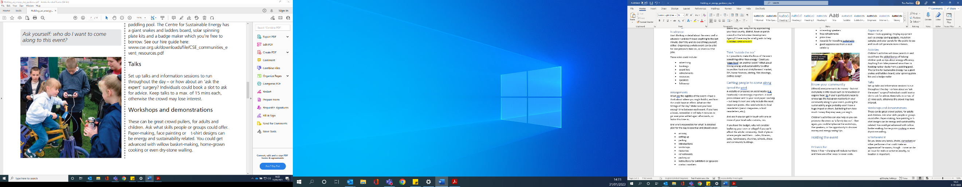
Activities
Children’s activities will draw parents in and could have the added bonus of helping children pick up tips about energy efficiency. Anything from bike powered smoothies to hooking rubber ducks from a paddling pool. The Centre for Sustainable Energy has activities such as solar spinning plate kits and a badge maker.

Talks
Set up talks and information sessions to run throughout the day – or how about an ‘ask the expert’ surgery? Individuals could book a slot to ask for advice. Keep talks to a max. of 15 mins each, otherwise the crowd may lose interest.

Workshops and demonstrations
These can be great crowd pullers, for adults and children. Ask what skills people or groups could offer. Paper-making, face painting or t-shirt designs can be energy and sustainability related. You could get advanced with willow basket-making, home-grown cooking or even dry-stone walling.

Entertainment
Do you know any bands, choirs, comedians or other performers that could make an appearance? Be aware, though – noise can be an issue for stalls or activities nearby, so location is important.

Raffles and prize draws
These go down well, and are good money-makers. They are great ways to get information from people if you want to do a follow-up. Be aware of data protection issues: make sure forms have somewhere for people to sign or tick to say they’re happy for you to contact them.

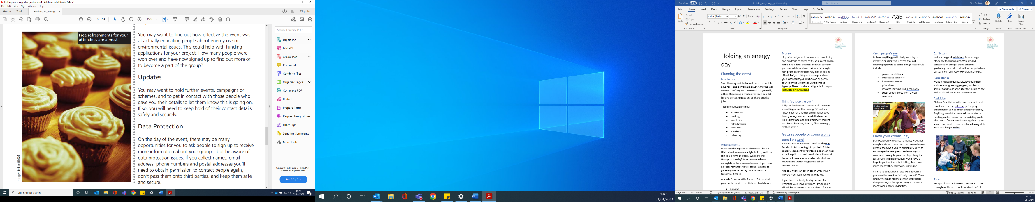
Refreshments
Essential. You need to offer tea, coffee and soft drinks (fair-trade and locally produced, if possible). Homemade cakes are a good draw – and people are often happy to donate if given notice. If you sell them, proceeds could go towards venue hire, other activities or future campaigns. There are health and safety and hygiene issues that need to be checked when offering food and drink.

Follow-up

Future events
Feedback and comments are very useful and could help you improve for next time or other projects you may be planning. You may want to get ideas about how what directions you want the group to go in. There are plenty of ways to do this:
- questionnaires
- comments box
- a post-it note wall (see below)
- talking to people for verbal feedback during or after the event
- Free refreshments for your attendees are a must

Impact

You may want to find out how effective the event was at actually educating people about energy use or environmental issues. This could help with funding applications for your project. How many people were won over and have now signed up to find out more or to become a part of the group?

Updates

You may want to hold further events, campaigns or schemes, and to get in contact with those people who gave you their details to let them know this is going on. If so, you will need to keep hold of their contact details safely and securely.

Data Protection

On the day of the event, there may be many opportunities for you to ask people to sign up to receive more information about your group – but be aware of data protection issues. If you collect names, email address, phone numbers and postal addresses you’ll need to obtain permission to contact people again, don’t pass them onto third parties, and keep them safe and secure.

Further help

Marketing and publicity
The Media Trust: Resource Hub | Media Trust
Free images from: unsplash.com
Creating posters and graphics: www.canva.com

Funding
Funding for all www.fundingforall.org.uk
360Giving GrantNav https://grantnav.threesixtygiving.org/
Charity Excellence Framework: sign up for free and search for trusts and foundations who are funding in similar work

Data protection
ICO guidance for organisations www.ico.org.uk/for-organisations/guide-to-data-protection/
Data protection guidance for community groups www.resourcecentre.org.uk/information/data-protection-for-community-groups/

Health and safety
HSE guidance on running an event
www.hse.gov.uk/event-safety/running.htm
HSE guidance on Health and Safety at work
Guidance on health and safety at work - HSE
Food standards Agency guidance
Homepage | Food Standards Agency

